**Revision 2022 UNIT 1**

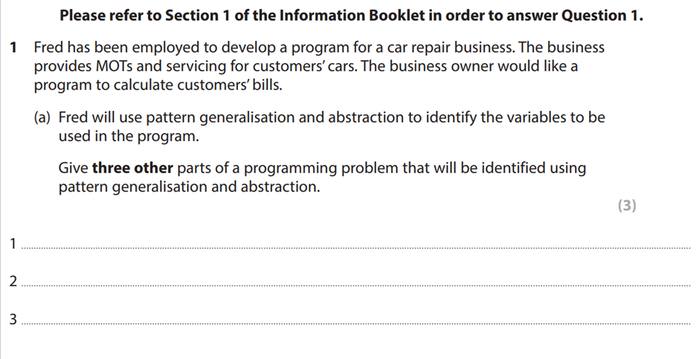

**Loops**

**Subroutines**

**Input / output**

**2022**

1)



i) which line performs calculations? (2)

**3,5,9,11,15,17**

ii) line of the code that uses branching. (2)

**2,4,8,10,14,16**

iii) line of the code that places item in a stack. (2)

**6,12,18**

b) identify 3 ways to the pseudocode in figure 2 could be improved. (3)

**- comments**

**- loops**

**- indent**

c) state two inputs the app needs to calculate the total score for each turn. (2)

**- dart score**

**- starting score**

d) the app uses stack, describe how stack handles data. (2)

data structure that stores items in a Last-In/First-Out (LIFO) is a pattern. This is where the first value is proceeded last, and the last value is proceeded first.

* **Data added to top of stack**
* **Most recent score will be at the top**

e) the score for each dart thrown during a player’s turn is held in a stack. Write a section of pseudocode that will produce the total score using the three scores held in stack. (4

**Total = 0**

**Score =0**

**For dart = 1 to 3**

**Pop value from stack**

**Total = total +value**

**Score = total**

**ENDFOR**

**NEXT dart**

1g)

The interface uses a trigger function for the update score button. Explain one other feature of event-driven programming that could be used in the app. (3)

A feature which can be used for this app is button hover. This function can highlight a certain area of the app. For this to occur, the user has their mouse hovered on the button furthermore this is beneficial to the user as it shows them they can click this button.

2) a petrol station uses a computer system to manage the fuel pumps and the digital price sign.

a) section2 of the information booklet shows details of the LED display units and how they work.

Complete array 3 and 4 to show how 115.8 will be stored. (2)

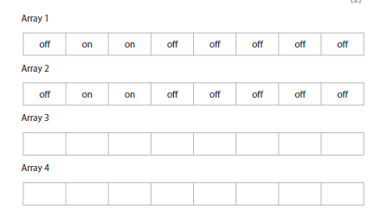

|  |  |  |  |  |  |  |  |
| --- | --- | --- | --- | --- | --- | --- | --- |
| **on** | **of** | **on** | **on** | **of** | **on** | **on** | **on** |
| **on** | **on** | **on** | **on** | **on** | **on** | **on** | **off** |

b) Describe one validation technique that could be used for the array. (2)

**Arrays could contain 8 values, in order to check this, we can use the function of length check**

c) Code needs to be developed to control the process for dispensing fuel and charging customers.

The programmer has identified the variables that would be needed.

State four other parts of the system that need to be identified to solve the problem. (4)

**key processes**

**constants**

**Input**

**Output**

2d)

a)

output item (2,3) **28.3** (1)

b)

Output integer item (1,3) **25** (1)

2e) The fuel pump measures the volume of fuel dispensed to 2 decimal places.

i)

**23.6**

ii)

**23.5**

iii)

**Less money is made by the garage, the reason for this is Because customers will pay less money as fuel is cheap.**

2f) A program is needed to find the total volume of fuel sold in example data.

Write pseudocode to calculate the total volume of fuel sold. The result should be rounded to the nearest litre. (6)

**Start**

**Volume_total =0**

**Volume_rounded =0**

**FOR row = 0 to 3**

**For col = 0 to 9**

**Volume_total = Volume_total + litres(row.col)**

**ENDFOR**

**ENDFOR**

**Volume_rounded = ROUND (Volume_total)**

**Output Volume_rounded**

**END**

3) A school keeps records for school visits and trips. The staff use a database to store all the information about pupils, payments and costs.

a) the user id must be between 5 and 30 characters.

Complete the IF statement used to test the user ID length. (3)

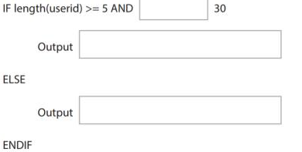

**<=**

**valid ID**

**Invalid ID**

b) explain the importance of ‘platform independence’ for users of the online database. (3)

**All users will be able to view all features and there will be no need to install additional software.**

C) flowchart

D) Code is needed to allow users to access the database through the school website.

Analyse the security implications of implementing code that will manipulate the database on a web platform.

Your answer should include security issues and ways in which these could be reduced. (10)

**General**

When implementing code, programmers should watch out for security implications and try their best to reduce security issues. This can be done in several ways, such as : protecting injection methods, broken autehntications.

**Injection methods**

**Broken authentication**

4) A hire shop is going to change the computer system it uses to keep records of the equipment it hires and the people who hire it.

a) the hire shop must change the existing code so that it will run on new hardware.

Discuss the implications of developing the new code and the impact this will have on the hire shop. (6)

**Implications**

**Impact**

b) Equipment hire and return dates need to be validated. The pseudocode used to do this is shown in Figure 6 of the information booklet.

Discuss the effectiveness of the code and any improvements that could be made (8)

**What works**

Variables: date, day, month, year are all stores as integer

**What is missing**

Does not have loops

Does not give message if valid

c) The hire shop wants to develop a website that customers can use to hire equipment. The website will use server side and client-side processing and scripting.

Analyse how the (12)

**General**

**Need to make the website interact with the customer, need to store data that customers enter on a web form.**

**Might want to validate the data before it is submitted or stored. This will need scripting of some kind.**

**Website scripts run in one or two places. The client side, front end. Server side, back end.**

**Server side**

**The processing takes place on the web server.**

**A script runs on the web server to generate HTML pages.**

**This HTML is then sent to the client browser.**

**It provides interactive web sites that can interface to databases on the server.**

**Client side**

**The processing times place on the user's computer.**

**The client side normally runs scripts in the browser.**

**The script is usually in JavaScript**

**The source code is transferred from the web server to the user’s computer over the internet and run directly from the browser.**

**Need to make the website interact**